Gas Grade Recommendations

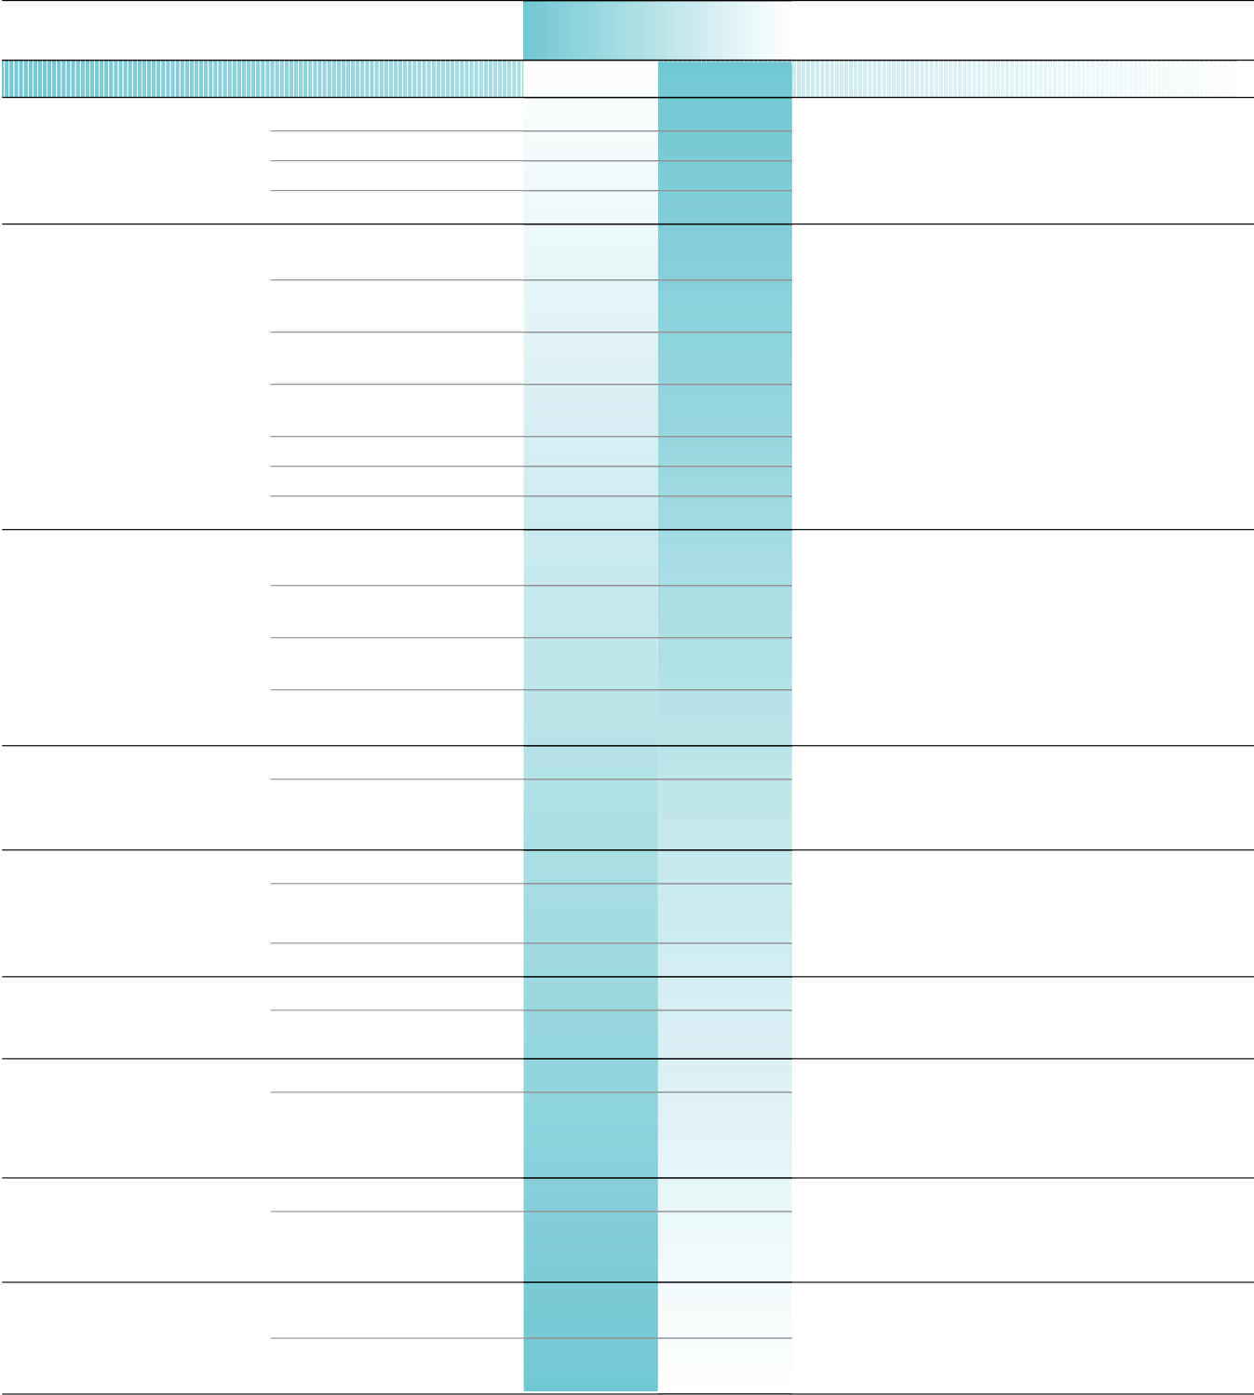
Analytical Method/ Carrier and
Detector Support Gases
Gas Chromatography
TCD N2
(Thermal Conductivity Detector) He H2
Ar
FID He
(Flame Ionization Detector)

Carriers N2

Ar

Combustion Gases H2

40% H 2 in He
40% H 2 in N 2
Air
ECD He
(Electron Capture Detector)
N2

Type of Analysis
Impurity Considerations

Universal Detector
Atmospheric contaminants can oxidize the detector ﬁlament giving rise to negative peaks and reduced sensitivity.

Organic Compounds
Hydrocarbons in carrier and fuel gases can give rise to baseline noise and reduced detector sensitivity. Oxygen and water cause column deterioration and affect retention time on critical separations.

Halogenated Compounds
Detector response and column life are reduced by oxygen and water. Hydrocarbons and halocarbons can produce baseline noise, negative peaks and

5% CH
4 in
plumbing contamination.

Ar-ECD (P-5)
10% CH 4 in Ar-ECD (P-10)
HID He
(Helium Ionization Detector) He Purge

FPD He
(Flame Photometric Detector) N2
H2
Air
PID He
(Photo Ionization Detector) N2

GC/MS He
(Mass Spectrometer) N2
Ar

DID He
(Discharge Ionization Detector) He Purge

USD Ar
(Ultrasonic Detector)
He

Universal Detector
Atmospheric impurities can cause baseline noise signal polarity and reduced detector stability and sensitivity.

Sulfur or Phosphorous Compounds
Organics can yield baseline noise and carbon dioxide can suppress detector response.

Selective Detector Dependent on UV Source Organics can yield baseline noise and carbon dioxide can suppress detector response.

All Compounds
Organics can yield baseline noise and carbon dioxide can suppress detector response.

Universal Detector
Atmospheric impurities can cause baseline noise signal polarity and reduced detector stability and sensitivity.

Universal Detector
Atmospheric impurities can cause baseline noise signal polarity and reduced detector stability and sensitivity

Gas Grade Recommendations



Analytical Method/ Carrier and
Detector Support Gases
Optical Spectometry – Adsorption
NDR(Non-dispersive Infrared) Air N2
IR (Dispersive Infrared)
-FTIR Ar
(Fourier Transform Infrared)

-FG/GFC N2
(Correlation)
AA (Atomic Absorption) C 2H2
Combustion Gases n-C 4H10
H2
N2O
Air
Ar (Flameless) N2
NMR LHe
(Nuclear Magnetic Resonance) LN 2

Type of Analysis
Impurity Considerations

Polyatomic and Heteroatomic Compounds Polyatomic and Heteroatomic Compounds
During matrix isolation, oxygen can oxidize a sample. Moisture interfers with IR spectra. Impurities coinciding with quantified peaks can cause inaccuracies.

Elemental Analysis
Impurites can cause the flame to discolor or burn unevenly. Furnace atmospheres require low oxygen and moisture levels to maintain instrument sensitivity.

Analysis of Molecular Structure

Legend
AA – Atomic Absorption
UH– Ultra High Purity
RS – Research/Chromatographic
Z – Zero
UZ – Ultra Zero
IS – Instrument
OF – Oxygen Free
TG – Trace Analytical
EC – Electron Capture Detector


Gas Grade Recommendations

Analytical Method/ Detector | Carrier and Support Gases | Type of Analysis  Impurity Considerations
Optical Spectrometry – Emission
Atomic Emission  - ICP (Inductive Coupled Plasma) | Ar | Elemental Analysis
Atomic Emission  - ICP (Inductive Coupled Plasma) | LAr | Elemental Analysis
Atomic Emission  - ICP (Inductive Coupled Plasma) | N2 | Elemental Analysis
Atomic Emission  - ICP (Inductive Coupled Plasma) | H2 | Elemental Analysis
Arc or Spark Emission | Ar | Elemental Analysis
Arc or Spark Emission | H2 | Elemental Analysis
Arc or Spark Emission | 5% Ar in H 2 | Elemental Analysis
Chemiluminescence | Air | NO-NO2 -NOX Hydrides and O3
Chemiluminescence | N2 | NO-NO2 -NOX Hydrides and O3
Chemiluminescence | O2 | NO-NO2 -NOX Hydrides and O3
Fluorescence UV | Air | SO2-H2S-Organic Compounds
Fluorescence UV | N2 | SO2-H2S-Organic Compounds
XRF (Fluorescence X) | 10% CH 4 in Ar | Elemental Analysis
XRF (Fluorescence X) | 1.3% n-C 4H10  in He | Elemental Analysis
XRF (Fluorescence X) | 0.95% i-C 4H10  in He | Elemental Analysis
XRF (Fluorescence X) | LN 2 | Elemental Analysis
Mass Spectrometry
MS (Under Vacuum) |  | All Compounds
MS (Under Vacuum) | N2 | All Compounds
MS (Under Vacuum) | He | All Compounds
Legend
UH – Ultra High Purity
RS – Research
IC – Inductive Coupled Plasma
CE – Continuous Emissions Monitoring (See Pure Gas Section for correct definition)
TG – Trace Analytical
Z – Zero
VC – Volatile Organic Compound Free
UZ – Ultra Zero


Gas Grade Recommendations

Analytical Method/ Carrier and Type of Analysis
Detector Support Gases Impurity Considerations
Others
Nuclear Counter | 10% CH 4 in Ar |  |  | Measurement of Radioactivity
Nuclear Counter | 1.3% n-C 4H10  in He |  |  | Measurement of Radioactivity
Nuclear Counter | 0.95% i-C 4H10  in He |  |  | Measurement of Radioactivity
Hydrometer | Air |  |  | Moisture in All Gas
Hydrometer | N2 |  |  | Moisture in All Gas
Paramagnetic Analyzer | N2 |  |  | Oxygen in All Gas
Paramagnetic Analyzer | O2 in N2 |  |  | Oxygen in All Gas
Carbon and Sulfur in Steel Ar He N2  O2 |  |  | Analysis of Carbon, Sulfur and Gases (N2-H2-O2) in Steel

Instrumentation Mixture Summary

Product Mixture
Description Application
40% H 2 in He (FID Fuel) Fuel Gas for GC-FID (THC < 0.5 ppm)
40% H 2 in He UHP (FID Fuel) Fuel Gas for GC-FID (THC < 0.1 ppm)
40% H 2 in N 2 (FID Fuel) Fuel Gas for GC-FID (THC < 0.5 ppm)
40% H 2 in N 2 UH (FID Fuel) Fuel Gas for GC-FID (THC < 0.1 ppm)
5% CH 4 in Argon-ECD (P-5) Make-up Gas for GC-ECD
10% CH 4 in Argon-ECD (P-10) Make-up Gas for GC-ECD
10% CH 4 in Ar (P-10) XRF (Fluorescence X)
1.3% n-C 4H10 in He XRF (Fluorescence X)
0.95% i-C 4H10 in He XRF (Fluorescence X)
5% CH 4 in Ar (P-5) Carrier Gas for Proportional Counters
10% CH 4 in Ar (P-10) Carrier Gas for Proportional Counters
1.3% n-C 4H10 in He Quench Gas
0.95% i-C 4H10 in He Carrier Gas for Geiger-Muller
5% Ar in H 2 Spark Emission

